# **Java Basic**

## What is Java

Java is a **programming language** and a **platform**.

Java is a high level, robust, secured and object-oriented programming language.

**Platform**: Any hardware or software environment in which a program runs, is known as a platform. Since Java has its own runtime environment (JRE) and API, it is called platform.

## Where it is used?

According to Sun, 3 billion devices run java. There are many devices where Java is currently used. Some of them are as follows:

1. Desktop Applications such as acrobat reader, media player, antivirus etc.
2. Web Applications such as irctc.co.in, javatpoint.com etc.
3. Enterprise Applications such as banking applications.
4. Mobile
5. Embedded System
6. Smart Card
7. Robotics
8. Games etc.

## Types of Java Applications

There are mainly 4 types of applications that can be created using java programming:

#### **1) Standalone Application**

It is also known as desktop application or window-based application. An application that we need to install on every machine such as media player, antivirus etc. AWT and Swing are used in java for creating standalone applications.

#### **2) Web Application**

An application that runs on the server side and creates dynamic page, is called web application. Currently, servlet, jsp, struts, jsf etc. technologies are used for creating web applications in java.

#### **3) Enterprise Application**

An application that is distributed in nature, such as banking applications etc. It has the advantage of high level security, load balancing and clustering. In java, EJB is used for creating enterprise applications.

#### **4) Mobile Application**

An application that is created for mobile devices. Currently Android and Java ME are used for creating mobile applications.

## Java Platforms / Editions

There are 4 platforms or editions of Java:

#### **1) Java SE (Java Standard Edition)**

It is a java programming platform. It includes Java programming APIs such as java.lang, java.io, java.net, java.util, java.sql, java.math etc. It includes core topics like OOPs, String, Regex, Exception, Inner classes, Multithreading, I/O Stream, Networking, AWT, Swing, Reflection, Collection etc.

#### **2) Java EE (Java Enterprise Edition)**

It is an enterprise platform which is mainly used to develop web and enterprise applications. It is built on the top of Java SE platform. It includes topics like Servlet, JSP, Web Services, EJB, JPA etc.

#### **3) Java ME (Java Micro Edition)**

It is a micro platform which is mainly used to develop mobile applications.

#### **4) JavaFx**

It is used to develop rich internet applications. It uses light-weight user interface API.

### **Java Version History**

There are many java versions that has been released. Current stable release of Java is Java SE 8.

1. JDK Alpha and Beta (1995)
2. JDK 1.0 (23rd Jan, 1996)
3. JDK 1.1 (19th Feb, 1997)
4. J2SE 1.2 (8th Dec, 1998)
5. J2SE 1.3 (8th May, 2000)
6. J2SE 1.4 (6th Feb, 2002)
7. J2SE 5.0 (30th Sep, 2004)
8. Java SE 6 (11th Dec, 2006)
9. Java SE 7 (28th July, 2011)
10. Java SE 8 (18th March, 2014)

# **Features of Java**

There is given many features of java. They are also known as java buzzwords. The Java Features given below are simple and easy to understand.

Java Features

1. Simple
2. Object-Oriented
3. Portable
4. Platform independent
5. Secured
6. Robust
7. Architecture neutral
8. Dynamic
9. Interpreted
10. High Performance
11. Multithreaded
12. Distributed

### **Simple**

|  |
| --- |
| According to Sun, Java language is simple because: |
| syntax is based on C++ (so easier for programmers to learn it after C++). |
| removed many confusing and/or rarely-used features e.g., explicit pointers, operator overloading etc. |
| No need to remove unreferenced objects because there is Automatic Garbage Collection in java. |

### **Object-oriented**

|  |
| --- |
| Object-oriented means we organize our software as a combination of different types of objects that incorporates both data and behaviour. |
| Object-oriented programming(OOPs) is a methodology that simplify software development and maintenance by providing some rules. |
| Basic concepts of OOPs are: |
| 1. Object 2. Class 3. Inheritance 4. Polymorphism 5. Abstraction 6. Encapsulation |

### **Platform Independent**

java is platform independent

A platform is the hardware or software environment in which a program runs.

There are two types of platforms software-based and hardware-based. Java provides software-based platform.

The Java platform differs from most other platforms in the sense that it is a software-based platform that runs on the top of other hardware-based platforms. It has two components:

1. Runtime Environment
2. API(Application Programming Interface)

Java code can be run on multiple platforms e.g. Windows, Linux, Sun Solaris, Mac/OS etc. Java code is compiled by the compiler and converted into bytecode. This bytecode is a platform-independent code because it can be run on multiple platforms i.e. Write Once and Run Anywhere(WORA).

### **Secured**

Java is secured because:

* **No explicit pointer**
* **Java Programs run inside virtual machine sandbox**

how java is secured

* **Classloader:** adds security by separating the package for the classes of the local file system from those that are imported from network sources.
* **Bytecode Verifier:** checks the code fragments for illegal code that can violate access right to objects.
* **Security Manager:** determines what resources a class can access such as reading and writing to the local disk.

These security are provided by java language. Some security can also be provided by application developer through SSL, JAAS, Cryptography etc.

### **Robust**

Robust simply means strong. Java uses strong memory management. There are lack of pointers that avoids security problem. There is automatic garbage collection in java. There is exception handling and type checking mechanism in java. All these points makes java robust.

### **Architecture-neutral**

There is no implementation dependent features e.g. size of primitive types is fixed.

In C programming, int data type occupies 2 bytes of memory for 32-bit architecture and 4 bytes of memory for 64-bit architecture. But in java, it occupies 4 bytes of memory for both 32 and 64 bit architectures.

### **Portable**

We may carry the java bytecode to any platform.

### **High-performance**

|  |
| --- |
| Java is faster than traditional interpretation since byte code is "close" to native code still somewhat slower than a compiled language (e.g., C++) |

### **Distributed**

|  |
| --- |
| We can create distributed applications in java. RMI and EJB are used for creating distributed applications. We may access files by calling the methods from any machine on the internet. |

### **Multi-threaded**

A thread is like a separate program, executing concurrently. We can write Java programs that deal with many tasks at once by defining multiple threads. The main advantage of multi-threading is that it doesn't occupy memory for each thread. It shares a common memory area. Threads are important for multi-media, Web applications etc.

# **C++ vs Java**

There are many differences and similarities between C++ programming language and Java. A list of top differences between C++ and Java are given below:

|  |  |  |
| --- | --- | --- |
| **Comparison Index** | **C++** | **Java** |
| Platform-independent | C++ is platform-dependent. | Java is platform-independent. |
| Mainly used for | C++ is mainly used for system programming. | Java is mainly used for application programming. It is widely used in window, web-based, enterprise and mobile applications. |
| Goto | C++ supports goto statement. | Java doesn't support goto statement. |
| Multiple inheritance | C++ supports multiple inheritance. | Java doesn't support multiple inheritance through class. It can be achieved by interfaces in java. |
| Operator Overloading | C++ supports operator overloading. | Java doesn't support operator overloading. |
| Pointers | C++ supports pointers. You can write pointer program in C++. | Java supports pointer internally. But you can't write the pointer program in java. It means java has restricted pointer support in java. |
| Compiler and Interpreter | C++ uses compiler only. | Java uses compiler and interpreter both. |
| Call by Value and Call by reference | C++ supports both call by value and call by reference. | Java supports call by value only. There is no call by reference in java. |
| Structure and Union | C++ supports structures and unions. | Java doesn't support structures and unions. |
| Thread Support | C++ doesn't have built-in support for threads. It relies on third-party libraries for thread support. | Java has built-in thread support. |
| Documentation comment | C++ doesn't support documentation comment. | Java supports documentation comment (/** ... */) to create documentation for java source code. |
| Virtual Keyword | C++ supports virtual keyword so that we can decide whether or not override a function. | Java has no virtual keyword. We can override all non-static methods by default. In other words, non-static methods are virtual by default. |
| unsigned right shift >>> | C++ doesn't support >>> operator. | Java supports unsigned right shift >>> operator that fills zero at the top for the negative numbers. For positive numbers, it works same like >> operator. |
| Inheritance Tree | C++ creates a new inheritance tree always. | Java uses single inheritance tree always because all classes are the child of Object class in java. Object class is the root of inheritance tree in java. |

**For executing any java program, you need to**

* install the JDK if you don't have installed it, [download the JDK](http://www.oracle.com/technetwork/java/javase/downloads/index.html) and install it.
* set path of the jdk/bin directory. <http://www.javatpoint.com/how-to-set-path-in-java>
* create the java program
* compile and run the java program
* To write the simple program, open notepad by **start menu -> All Programs -> Accessories -> notepad** and write simple program as displayed below:

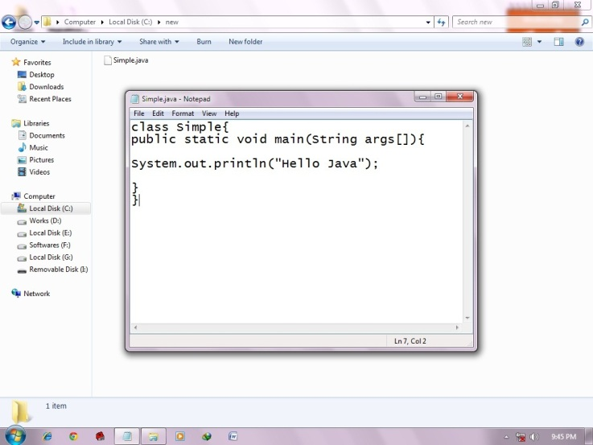 

|  |
| --- |
| As displayed in the above diagram, write the simple program of java in notepad and saved it as Simple.java. To compile and run this program, you need to open command prompt by **start menu -> All Programs -> Accessories -> command prompt**. |

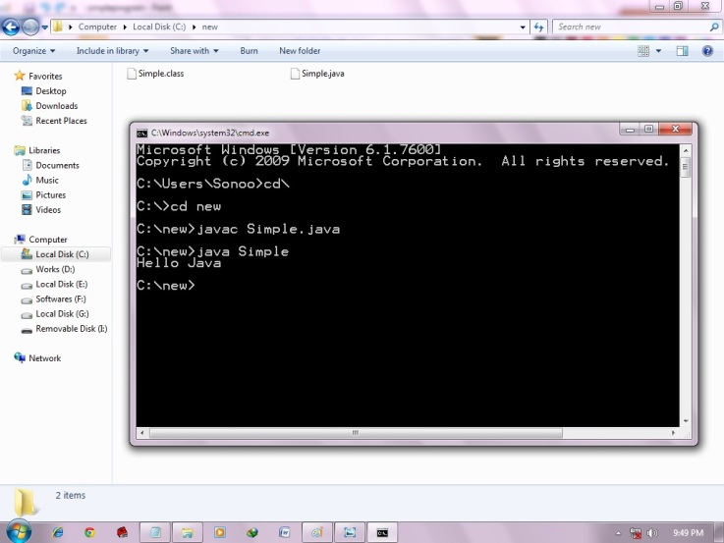 

|  |
| --- |
| To compile and run the above program, go to your current directory first; my current directory is c:\new . Write here: |

|  |  |
| --- | --- |
| **To compile:** | javac Simple.java |
| **To execute:** | java Simple |

## How many ways can we write a java program

There are many ways to write a java program. The modifications that can be done in a java program are given below:

**1) By changing sequence of the modifiers, method prototype is not changed.**

Let's see the simple code of main method.

1. **static** **public** **void** main(String args[])

**2) subscript notation in java array can be used after type, before variable or after variable.**

Let's see the different codes to write the main method.

1. **public** **static** **void** main(String[] args)
2. **public** **static** **void** main(String []args)
3. **public** **static** **void** main(String args[])

**3) You can provide var-args support to main method by passing 3 ellipses (dots)**

Let's see the simple code of using var-args in main method. We will learn about var-args later in Java New Features chapter.

1. **public** **static** **void** main(String... args)

**4) Having semicolon at the end of class in java is optional.**

Let's see the simple code.

1. **class** A{
2. **static** **public** **void** main(String... args){
3. System.out.println("hello java4");
4. }
5. };

## Valid java main method signature

1. **public** **static** **void** main(String[] args)
2. **public** **static** **void** main(String []args)
3. **public** **static** **void** main(String args[])
4. **public** **static** **void** main(String... args)
5. **static** **public** **void** main(String[] args)
6. **public** **static** **final** **void** main(String[] args)
7. **final** **public** **static** **void** main(String[] args)
8. **final** **strictfp** **public** **static** **void** main(String[] args)

## Invalid java main method signature

1. **public** **void** main(String[] args)
2. **static** **void** main(String[] args)
3. **public** **void** **static** main(String[] args)
4. **abstract** **public** **static** **void** main(String[] args)

### **Resolving an error "javac is not recognized as an internal or external command" ?**

If there occurs a problem like displayed in the below figure, you need to set path. Since DOS doesn't know javac or java, we need to set path. Path is not required in such a case if you save your program inside the jdk/bin folder. But its good approach to set path. Click here for [How to set path in java](https://www.javatpoint.com/how-to-set-path-in-java).

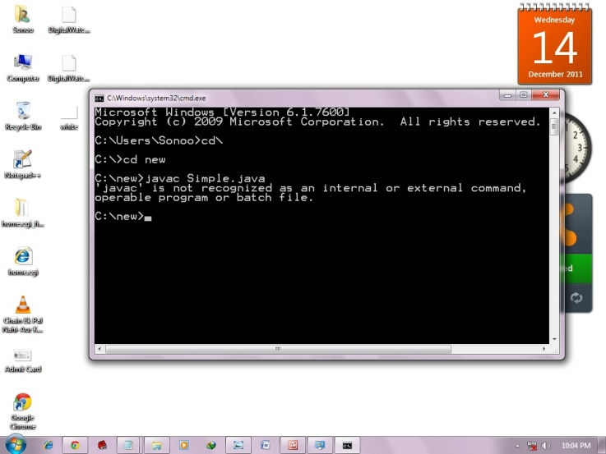

Open up Windows' System Properties from the control panel and hunt down the environment variables section:

* Add a JAVA_HOME entry pointing to the directory where the JDK is installed (e.g. C:\Program Files\Java\jre6)
* Find the Path entry and add the following onto the end ;%JAVA_HOME%\bin
* OK the changes
* Restart eclipse so that it is aware of the new environment

## What happens at compile time?

At compile time, java file is compiled by Java Compiler (It does not interact with OS) and converts the java code into bytecode.

compilation of simple java program

## What happens at runtime?

|  |
| --- |
| At runtime, following steps are performed: |
| what happens at runtime when simple java program runs |

|  |
| --- |
| **Classloader:**is the subsystem of JVM that is used to load class files. |
| **Bytecode Verifier:**checks the code fragments for illegal code that can violate access right to objects. |
| **Interpreter:**read bytecode stream then execute the instructions. |

### **JVM**

JVM (Java Virtual Machine) is an abstract machine. It is a specification that provides runtime environment in which java bytecode can be executed.

JVMs are available for many hardware and software platforms. JVM, JRE and JDK are platform dependent because configuration of each OS differs. But, Java is platform independent.

The JVM performs following main tasks:

* Loads code
* Verifies code
* Executes code
* Provides runtime environment

### **JVM**

JVM (Java Virtual Machine) is an abstract machine. It is a specification that provides runtime environment in which java bytecode can be executed.

JVMs are available for many hardware and software platforms. JVM, JRE and JDK are platform dependent because configuration of each OS differs. But, Java is platform independent.

The JVM performs following main tasks:

* Loads code
* Verifies code
* Executes code
* Provides runtime environment

### **JRE**

JRE is an acronym for Java Runtime Environment.It is used to provide runtime environment.It is the implementation of JVM. It physically exists. It contains set of libraries + other files that JVM uses at runtime.

Implementation of JVMs are also actively released by other companies besides Sun Micro Systems.

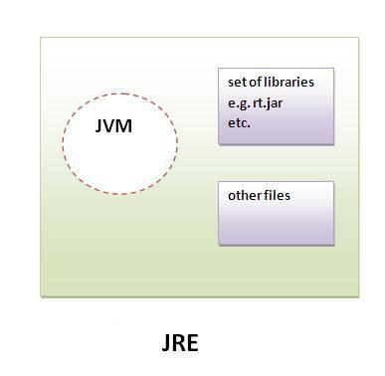

### **JDK**

JDK is an acronym for Java Development Kit.It physically exists.It contains JRE + development tools.

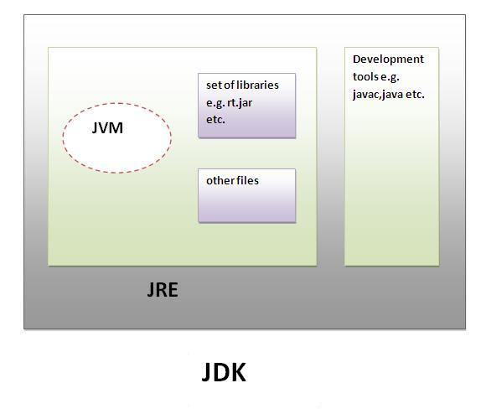

### **JVM**

JVM (Java Virtual Machine) is an abstract machine. It is a specification that provides runtime environment in which java bytecode can be executed.

JVMs are available for many hardware and software platforms. JVM, JRE and JDK are platform dependent because configuration of each OS differs. But, Java is platform independent.

The JVM performs following main tasks:

* Loads code
* Verifies code
* Executes code
* Provides runtime environment

### **JRE**

JRE is an acronym for Java Runtime Environment.It is used to provide runtime environment.It is the implementation of JVM. It physically exists. It contains set of libraries + other files that JVM uses at runtime.

Implementation of JVMs are also actively released by other companies besides Sun Micro Systems.



### **JDK**

JDK is an acronym for Java Development Kit.It physically exists.It contains JRE + development tools.



# **Variables and Data Types in Java**

Variable is a name of memory location. There are three types of variables in java: local, instance and static.

There are two types of data types in java: primitive and non-primitive.

## Variable

**Variable** is name of reserved area allocated in memory. In other words, it is a name of memory location. It is a combination of "vary + able" that means its value can be changed.

variables in java

1. **int** data=50;//Here data is variable

### **Types of Variable**

There are three types of variables in java:

* local variable
* instance variable
* static variable

types of variables in java

#### **1) Local Variable**

A variable which is declared inside the method is called local variable.

#### **2) Instance Variable**

A variable which is declared inside the class but outside the method, is called instance variable . It is not declared as static.

#### **3) Static variable**

A variable that is declared as static is called static variable. It cannot be local.

We will have detailed learning of these variables in next chapters.

### **Example to understand the types of variables in java**

1. **class** A{
2. **int** data=50;//instance variable
3. **static** **int** m=100;//static variable
4. **void** method(){
5. **int** n=90;//local variable
6. }
7. }//end of class

## Data Types in Java

Data types represent the different values to be stored in the variable. In java, there are two types of data types:

* Primitive data types
* Non-primitive data types

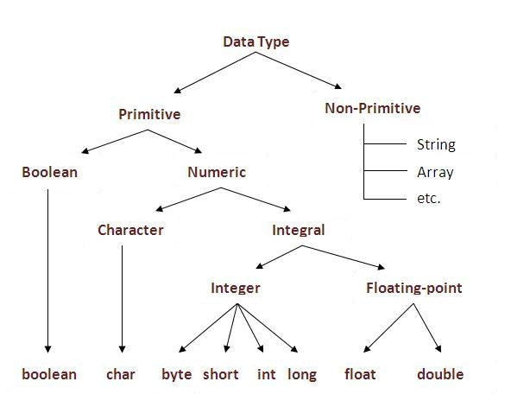

|  |  |  |
| --- | --- | --- |
| **Data Type** | **Default Value** | **Default size** |
| boolean | false | 1 bit |
| char | '\u0000' | 2 byte |
| byte | 0 | 1 byte |
| short | 0 | 2 byte |
| int | 0 | 4 byte |
| long | 0L | 8 byte |
| float | 0.0f | 4 byte |
| double | 0.0d | 8 byte |

### **Why char uses 2 byte in java and what is \u0000 ?**

It is because java uses Unicode system than ASCII code system. The \u0000 is the lowest range of Unicode system. To get detail explanation about Unicode visit next page.

### **Java Variable Example: Add Two Numbers**

1. **class** Simple{
2. **public** **static** **void** main(String[] args){
3. **int** a=10;
4. **int** b=10;
5. **int** c=a+b;
6. System.out.println(c);
7. }}

Output:

20

### **Java Variable Example: Widening**

1. **class** Simple{
2. **public** **static** **void** main(String[] args){
3. **int** a=10;
4. **float** f=a;
5. System.out.println(a);
6. System.out.println(f);
7. }}

Output:

10

10.0

### **Java Variable Example: Narrowing (Typecasting)**

1. **class** Simple{
2. **public** **static** **void** main(String[] args){
3. **float** f=10.5f;
4. //int a=f;//Compile time error
5. **int** a=(**int**)f;
6. System.out.println(f);
7. System.out.println(a);
8. }}

Output:

10.5

10

### **Java Variable Example: Overflow**

1. **class** Simple{
2. **public** **static** **void** main(String[] args){
3. //Overflow
4. **int** a=130;
5. **byte** b=(**byte**)a;
6. System.out.println(a);
7. System.out.println(b);
8. }}

Output:

130

-126

### **Java Variable Example: Adding Lower Type**

1. **class** Simple{
2. **public** **static** **void** main(String[] args){
3. **byte** a=10;
4. **byte** b=10;
5. //byte c=a+b;//Compile Time Error: because a+b=20 will be int
6. **byte** c=(**byte**)(a+b);
7. System.out.println(c);
8. }}

Output:

20

# **Unicode System**

|  |
| --- |
| Unicode is a universal international standard character encoding that is capable of representing most of the world's written languages. |

### **Why java uses Unicode System?**

|  |
| --- |
| Before Unicode, there were many language standards: |
| * **ASCII** (American Standard Code for Information Interchange) for the United States. * **ISO 8859-1** for Western European Language. * **KOI-8** for Russian. * **GB18030 and BIG-5** for chinese, and so on. |

## Problem

|  |
| --- |
| **This caused two problems:**   1. A particular code value corresponds to different letters in the various language standards. 2. The encodings for languages with large character sets have variable length.Some common characters are encoded as single bytes, other require two or more byte. |

## Solution

|  |
| --- |
| To solve these problems, a new language standard was developed i.e. Unicode System. |
| In unicode, character holds 2 byte, so java also uses 2 byte for characters. |
| **lowest value:**\u0000 |
| **highest value:**\uFFFF |

# **Operators in java**

**Operator** in java is a symbol that is used to perform operations. For example: +, -, *, / etc.

There are many types of operators in java which are given below:

* Unary Operator,
* Arithmetic Operator,
* shift Operator,
* Relational Operator,
* Bitwise Operator,
* Logical Operator,
* Ternary Operator and
* Assignment Operator.

## Java Operator Precedence

|  |  |  |
| --- | --- | --- |
| **Operator Type** | **Category** | **Precedence** |
| Unary | postfix | expr++ expr-- |
| prefix | ++expr --expr +expr -expr ~ ! |
| Arithmetic | multiplicative | * / % |
| additive | + - |
| Shift | shift | << >> >>> |
| Relational | comparison | < > <= >= instanceof |
| equality | == != |
| Bitwise | bitwise AND | & |
| bitwise exclusive OR | ^ |
| bitwise inclusive OR | | |
| Logical | logical AND | && |
| logical OR | || |
| Ternary | ternary | ? : |
| Assignment | assignment | = += -= *= /= %= &= ^= |= <<= >>= >>>= |

### **Java Unary Operator Example: ++ and --**

1. **class** OperatorExample{
2. **public** **static** **void** main(String args[]){
3. **int** x=10;
4. System.out.println(x++);//10 (11)
5. System.out.println(++x);//12
6. System.out.println(x--);//12 (11)
7. System.out.println(--x);//10
8. }}

Output:

10

12

12

10

### **Java Unary Operator Example 2: ++ and --**

1. **class** OperatorExample{
2. **public** **static** **void** main(String args[]){
3. **int** a=10;
4. **int** b=10;
5. System.out.println(a++ + ++a);//10+12=22
6. System.out.println(b++ + b++);//10+11=21
8. }}

Output:

22

21

### **Java Unary Operator Example: ~ and !**

1. **class** OperatorExample{
2. **public** **static** **void** main(String args[]){
3. **int** a=10;
4. **int** b=-10;
5. **boolean** c=**true**;
6. **boolean** d=**false**;
7. System.out.println(~a);//-11 (minus of total positive value which starts from 0)
8. System.out.println(~b);//9 (positive of total minus, positive starts from 0)
9. System.out.println(!c);//false (opposite of boolean value)
10. System.out.println(!d);//true
11. }}

Output:

-11

9

false

true

### **Java Arithmetic Operator Example**

1. **class** OperatorExample{
2. **public** **static** **void** main(String args[]){
3. **int** a=10;
4. **int** b=5;
5. System.out.println(a+b);//15
6. System.out.println(a-b);//5
7. System.out.println(a*b);//50
8. System.out.println(a/b);//2
9. System.out.println(a%b);//0
10. }}

Output:

15

5

50

2

0

### **Java Arithmetic Operator Example: Expression**

1. **class** OperatorExample{
2. **public** **static** **void** main(String args[]){
3. System.out.println(10*10/5+3-1*4/2);
4. }}

Output:

21

### **Java Shift Operator Example: Left Shift**

1. **class** OperatorExample{
2. **public** **static** **void** main(String args[]){
3. System.out.println(10<<2);//10*2^2=10*4=40
4. System.out.println(10<<3);//10*2^3=10*8=80
5. System.out.println(20<<2);//20*2^2=20*4=80
6. System.out.println(15<<4);//15*2^4=15*16=240
7. }}

Output:

40

80

80

240

### **Java Shift Operator Example: Right Shift**

1. **class** OperatorExample{
2. **public** **static** **void** main(String args[]){
3. System.out.println(10>>2);//10/2^2=10/4=2
4. System.out.println(20>>2);//20/2^2=20/4=5
5. System.out.println(20>>3);//20/2^3=20/8=2
6. }}

Output:

2

5

2

### **Java Shift Operator Example: >> vs >>>**

1. **class** OperatorExample{
2. **public** **static** **void** main(String args[]){
3. //For positive number, >> and >>> works same
4. System.out.println(20>>2);
5. System.out.println(20>>>2);
6. //For nagative number, >>> changes parity bit (MSB) to 0
7. System.out.println(-20>>2);
8. System.out.println(-20>>>2);
9. }}

Output:

5

5

-5

1073741819

### **Java AND Operator Example: Logical && and Bitwise &**

The logical && operator doesn't check second condition if first condition is false. It checks second condition only if first one is true.

The bitwise & operator always checks both conditions whether first condition is true or false.

1. **class** OperatorExample{
2. **public** **static** **void** main(String args[]){
3. **int** a=10;
4. **int** b=5;
5. **int** c=20;
6. System.out.println(a<b&&a<c);//false && true = false
7. System.out.println(a<b&a<c);//false & true = false
8. }}

Output:

false

false

### **Java AND Operator Example: Logical && vs Bitwise &**

1. **class** OperatorExample{
2. **public** **static** **void** main(String args[]){
3. **int** a=10;
4. **int** b=5;
5. **int** c=20;
6. System.out.println(a<b&&a++<c);//false && true = false
7. System.out.println(a);//10 because second condition is not checked
8. System.out.println(a<b&a++<c);//false && true = false
9. System.out.println(a);//11 because second condition is checked
10. }}

Output:

false

10

false

11

### **Java OR Operator Example: Logical || and Bitwise |**

The logical || operator doesn't check second condition if first condition is true. It checks second condition only if first one is false.

The bitwise | operator always checks both conditions whether first condition is true or false.

1. **class** OperatorExample{
2. **public** **static** **void** main(String args[]){
3. **int** a=10;
4. **int** b=5;
5. **int** c=20;
6. System.out.println(a>b||a<c);//true || true = true
7. System.out.println(a>b|a<c);//true | true = true
8. //|| vs |
9. System.out.println(a>b||a++<c);//true || true = true
10. System.out.println(a);//10 because second condition is not checked
11. System.out.println(a>b|a++<c);//true | true = true
12. System.out.println(a);//11 because second condition is checked
13. }}

Output:

true

true

true

10

true

11

### **Java Ternary Operator Example**

1. **class** OperatorExample{
2. **public** **static** **void** main(String args[]){
3. **int** a=2;
4. **int** b=5;
5. **int** min=(a<b)?a:b;
6. System.out.println(min);
7. }}

Output:

2

Another Example:

1. **class** OperatorExample{
2. **public** **static** **void** main(String args[]){
3. **int** a=10;
4. **int** b=5;
5. **int** min=(a<b)?a:b;
6. System.out.println(min);
7. }}

Output:

5

### **Java Assignment Operator Example**

1. **class** OperatorExample{
2. **public** **static** **void** main(String args[]){
3. **int** a=10;
4. **int** b=20;
5. a+=4;//a=a+4 (a=10+4)
6. b-=4;//b=b-4 (b=20-4)
7. System.out.println(a);
8. System.out.println(b);
9. }}

Output:

14

16

### **Java Assignment Operator Example**

1. **class** OperatorExample{
2. **public** **static** **void** main(String[] args){
3. **int** a=10;
4. a+=3;//10+3
5. System.out.println(a);
6. a-=4;//13-4
7. System.out.println(a);
8. a*=2;//9*2
9. System.out.println(a);
10. a/=2;//18/2
11. System.out.println(a);
12. }}

Output:

13

9

18

9

### **Java Assignment Operator Example: Adding short**

1. **class** OperatorExample{
2. **public** **static** **void** main(String args[]){
3. **short** a=10;
4. **short** b=10;
5. //a+=b;//a=a+b internally so fine
6. a=a+b;//Compile time error because 10+10=20 now int
7. System.out.println(a);
8. }}

Output:

Compile time error

After type cast:

1. **class** OperatorExample{
2. **public** **static** **void** main(String args[]){
3. **short** a=10;
4. **short** b=10;
5. a=(**short**)(a+b);//20 which is int now converted to short
6. System.out.println(a);
7. }}

Output:

20